District V Vice President Celebration  Honoring Cheryl Schmandt  2023-2024 District V Vice President  This event is sponsored by the Eastern Michigan Council and Cardinal Crossroads Council  JULY 12 & 13, 2024  KENSINGTON HOTEL / 3500 S. State Street, Ann Arbor, MI 48108  Friday, July 12 - 5:00 p.m. Informal Meet & Greet  6:00 p.m. groups go to different restaurants – CHECK boxes here  Saturday, July 13 – 8:30 a.m. to 3:30 p.m. Main Event  (BRUNCH BUFFET INCLUDED – See Agenda and Menu Below)  Early Registration $50 by June 15 (cash, check, Zelle, or PayPal*)  ☐ I will Pay via Zelle ☐ I will mail a CHECK made payable to ABWA  ☐ I will Pay via PayPal* to Financial Chair Jo Ann Huebner  www.abwa-emc.org/dvp-luncheon 331 Antoinette Dr., Rochester Hills, MI 48309  *Fees will be added to all PayPal payments.  Late Registration $55 June 16 to July 8 (online Zelle or PayPal* only) | 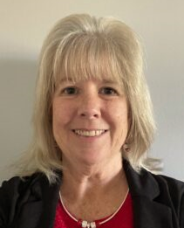  CHERYL SCHMANDT  CLICK the BOXES  ☐ I WILL ATTEND  the Friday  Meet & Greet  ☐ I WILL GO to Friday dinner with a group (locations to be announced)  ☐ PLEASE PUT ME IN THE DRAWING FOR THE $300 CONFERENCE SCHOLARSHIPS!
SATURDAY AGENDA: QUESTIONS? Contact event Quad-Chairs:
JOIN US!
Networking, Silent Auction, Envelope Pull, Cork Pull, Recognition & Contributions!
We will award EIGHT $300 scholarships for the 2024 National Women’s Leadership Conference!

8:30 a.m. Registration Opens Julie Sullivan ABWAJulie@gmail.com
9:00 a.m. Welcome & Introductions Vicky Vincent vickylee12766@gmail.com
9:15 a.m. Educational Speaker Tracy Sweet sweet.tracy1@gmail.com
10:45 a.m. Group Pictures Paula Clutter clutterp128@gmail.com
11:00 a.m. Brunch *
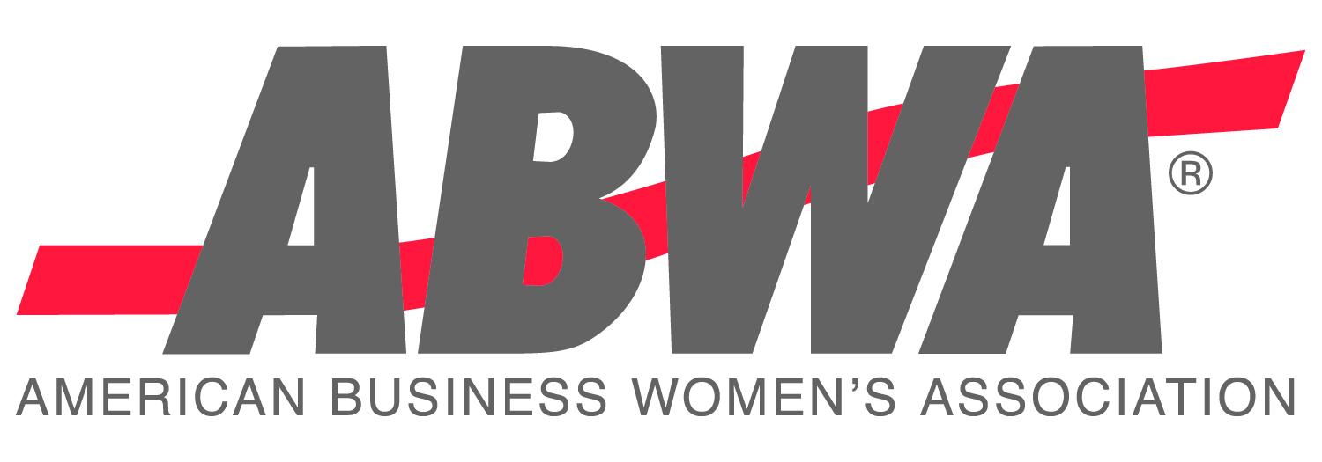
1:00 p.m. Vice President Honors Event
*Scrambled eggs, breakfast potatoes, bacon, sausage, French toast, fresh fruit, garden salad, Caprese pasta salad, roasted vegetables, herb roasted chicken breast with Michigan sundried tomato cream sauce, and garlic mashed potatoes.
Coffee and tea station, and orange and cranberry juice.
USE FOR CASH OR CHECK PAYMENTS ONLY. Use the tab key to go from field to field below.
NAME: |  |  |  |  |  |  | EMAIL:
STREET ADDRESS: |  |  |  |  |  |  |  |  |  |  | TOTAL ENCLOSED: $
City, State, Zip:
Phone: |  |  |  |  |  | Nat’l Officer or Top Ten:
 |  |  |  |  |  |  |  |  |  |  |  | Title and Year
Chapter / Guest of: |  |  |  |  |  |  |  | Food restrictions:
Additional names for whom you bought tickets (and chapter and/or honors, if applicable):
To attend this event ($50), register at www.abwa-emc.org/dvp-luncheon
KENSINGTON HOTEL RESERVATIONS $159/night – up to 4 people / (734) 761-2929
https://reservations.travelclick.com/113707?groupID=3949642: USE CODE 2407ABWADV
Via phone, use code ABWA DVP. Must make the hotel reservation before June 12, 2024
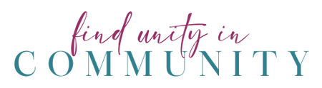
CHERYL’S FAVORITE COLOR IS PINK! LET’S WEAR IT TO SUPPORT HER!

