District V Vice President Celebration
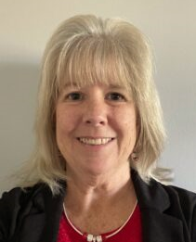
CHERYL SCHMANDT
Honoring Cheryl Schmandt
2023-2024 District V Vice President
This event is sponsored by the Eastern Michigan Council and Cardinal Crossroads Council
JULY 12 & 13, 2024 / KENSINGTON HOTEL
3500 S. State Street, Ann Arbor, MI 48108
Event Sponsorship Opportunities – Deadline may 15, 2024
All sponsorship levels include an Eastern Michigan Council website listing with your logo and a link to your website, and recognition on our EMC social media platforms (FaceBook and Instagram). Please CLICK the CHECKBOXES that apply
☐ OPTION 1: Event Sponsor - $1,200 | ☐ OPTION 3: Friday Meet & Greet Sponsor - $500
- VIP table at the Saturday event with six Admission Tickets and table top sign  - Full Page ad in Event Program  - Sponsor can display a 6- to 8-foot Banner or Sign at the Event  - Your Corporate Greeter may welcome attendees as they arrive  - Sponsor may provide a small promotional item for up to 100 attendees at the Saturday Registration Table | - Four Admission Tickets to the Saturday event  - Half-Page ad in Event Program  - Sponsor can display a 3- to 4-foot Banner or Sign at the Event  - Sponsor may provide a small promotional item for up to 40 attendees at the Friday welcome table  - Two Corporate Greeters may welcome attendees as they arrive at the Friday night Meet & Greet event  - Opportunity to present a 5-minute pitch on their company
☐ OPTION 2: Table Sponsor - $500 | ☐ OPTION 4: Program Book Sponsor - $300
- Reserved table at the Saturday event with four Admission Tickets and table top sign  - Half-Page ad in Event Program  - Sponsor can display a 3- to 4-foot Banner or Sign at the Event  - Sponsor may provide a small promotional item for up to 100 attendees at the Saturday Registration Table | - Two Admission Tickets to the Saturday event  - Quarter-Page ad in Event Program  - Sponsor can display a 11” x 14” Sign at the Saturday Registration Table  - Sponsor may provide a small promotional item for up to 100 attendees at the Saturday Registration Table
☐ I will Pay via Zelle ☐ I will mail a CHECK made payable to ABWA
☐ I will Pay via PayPal* to Financial Chair Jo Ann Huebner
www.abwa-emc.org/dvp-luncheon 331 Antoinette Dr., Rochester Hills, MI 48309
*Fees will be added to all PayPal payments. PLEASE EMAIL FORM TO ABWA.EMC@GMAIL.COM
COMPLETE AND SAVE THIS FILE WITH YOUR NAME. Use the tab key to go from field to field below.
CONTACT: |  |  |  | EMAIL:
Name of person, company, or organization sponsoring the event (as you want it listed in the souvenir program):
REQUESTS? |  |  |  |  |  | PHONE:
 |  |  | TOTAL CONTRIBUTION: $
You may download event fliers to share with others at www.abwa-emc.org/dvp-luncheon
To attend this event ($50), register at www.abwa-emc.org/dvp-luncheon
KENSINGTON HOTEL RESERVATIONS $159/night – up to 4 people / (734) 761-2929
https://reservations.travelclick.com/113707?groupID=3949642: USE CODE 2407ABWADV
Via phone, use code ABWA DVP. Must make the hotel reservation before June 12, 2024
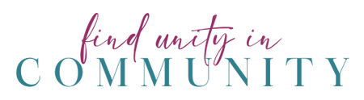
CHERYL’S FAVORITE COLOR IS PINK! LET’S WEAR IT TO SUPPORT HER!

