District V Vice President Celebration
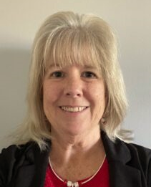
CHERYL SCHMANDT
Honoring Cheryl Schmandt
2023-2024 District V Vice President
This event is sponsored by the Eastern Michigan Council and Cardinal Crossroads Council
JULY 12 & 13, 2024 / KENSINGTON HOTEL
3500 S. State Street, Ann Arbor, MI 48108
Fundraisers: Silent Auction, Envelope Pull, & Cork Pull
Donations of silent auction items ($25-$50 or more), gift cards (at least $10), and wine (minimum $10 value) are requested from individuals, ABWA chapters and councils, and local businesses. Proceeds help fund our annual DVP celebration, District V national officer candidates, and registrations for the
ABWA National Women’s Leadership Conference (NWLC) – in 2024, the 75th Anniversary of ABWA.
THE DONATION SUBMISSION DEADLINE IS JUNE 15, 2024
Donations after that date will not be recognized in the souvenir program.
Thank you for donating!! Please complete the form below and save the file with your name.
Email your completed form to the Eastern Michigan Council at abwa.emc@gmail.com
☐ I AM DONATING TO THE ENVELOPE PULL: ☐ I AM DONATING TO THE SILENT AUCTION:
National chain cards / Minimum $10 value Value of donations should be $25 to $50 minimum.
Receiver pays $10 for an envelope New items / baskets of items. Requesting two to
Direct dollar donations are welcome (we buy the cards) four donations from chapters, if possible
Susie Mariutto smariutto@ameritech.net Mary Ceccanese mary.ceccanese@gmail.com
Chris Struwe cbstruweABWA87@gmail.com Gail Frahm gailfrahm@aim.com
☐ I AM DONATING TO THE CORK PULL (WINES): Sharon Walker walkers@med.umich.edu
Wine of minimum $10 value. Receiver pays $10 to Cyd Rice abwacyd@aol.com
“pull” a numbered cork and receives a bottle of wine. Cheryl Swarts ladyracr73@comcast.net
Direct dollar donations are welcome (we buy the wine) Dianne Hoover diannehoover29@gmail.com
Leigh Roberson leigh@thegadgetgirlllc.com QUESTIONS? Contact the section Co-Chairs listed.

COMPLETE AND SAVE THIS FILE WITH YOUR NAME. Use the tab key to go from field to field below.
CONTACT: |  |  |  | EMAIL:
Name of person, company, or organization making the donation (as you want it listed in the souvenir program):
COMMENTS? |  |  |  |  |  | PHONE:
PLEASE LIST DONATIONS ON SEPARATE LINES:
DESCRIPTION 1: |  |  |  |  |  |  |  | RETAIL VALUE: $
DESCRIPTION 2: |  |  |  |  |  |  |  | RETAIL VALUE: $
DESCRIPTION 3: |  |  |  |  |  |  |  | RETAIL VALUE: $
DESCRIPTION 4: |  |  |  |  |  |  |  | RETAIL VALUE: $
DESCRIPTION 5: |  |  |  |  |  |  |  | RETAIL VALUE: $
To attend this event ($50), register at www.abwa-emc.org/dvp-luncheon
KENSINGTON HOTEL RESERVATIONS $159/night – up to 4 people / (734) 761-2929
https://reservations.travelclick.com/113707?groupID=3949642: USE CODE 2407ABWADV
Via phone, use code ABWA DVP. Must make the hotel reservation before June 12, 2024
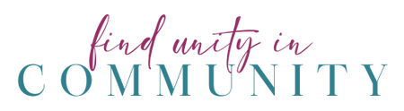
CHERYL’S FAVORITE COLOR IS PINK! LET’S WEAR IT TO SUPPORT HER!

