District V Vice President Celebration
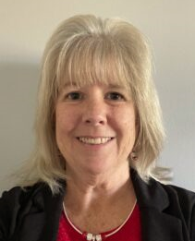
CHERYL SCHMANDT
Honoring Cheryl Schmandt
2023-2024 District V Vice President
This event is sponsored by the Eastern Michigan Council and Cardinal Crossroads Council
JULY 12 & 13, 2024
KENSINGTON HOTEL / 3500 S. State Street, Ann Arbor, MI 48108
Souvenir Program Advertising
You may advertise your business, promote your event, send Cheryl a message, and much more. Attendees are from Michigan, Indiana, Ohio, and other states across the country.
THE AD SUBMISSION DEADLINE IS JUNE 15, 2024
Need help with your design? Submission deadline is June 1, 2024.
Ad files and payment must be received by the deadlines above.
☐ I will Pay via Zelle ☐ I will mail a CHECK made payable to ABWA
☐ I will Pay via PayPal* to Financial Chair Jo Ann Huebner
www.abwa-emc.org/dvp-luncheon 331 Antoinette Dr., Rochester Hills, MI 48309
*Fees will be added to all PayPal payments.
AD SIZES AND COSTS: Email your completed ad (pdf or jpg 300 DPI)
- Patron Ad - 2 lines, 65 characters per line $10 or QUESTIONS to Souvenir Program Co-Chairs:
- Business Card size $25 Cheryl Cramer Cheryl.Cramer.2007@gmail.com
- 2.25” wide x 3.25” tall $35 Lynn Pomerleau store7584@theupsstore.com
- 4.50” wide x 3.25” tall $50
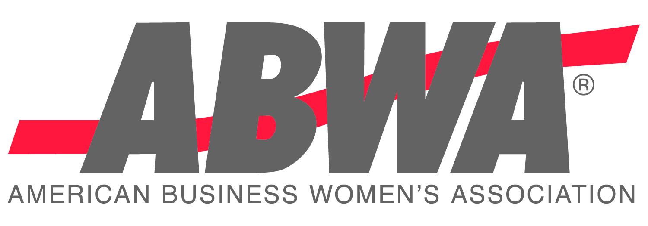
- 4.50” wide x 7.50” tall $100
- Cover / Inside or Out - 4.5” wide x 7.5” tall $150

COMPLETE AND SAVE THIS FILE WITH YOUR NAME. Use the tab key to go from field to field below.
CONTACT: |  |  |  |  |  | EMAIL:
Name of your company or organization:
STREET ADDRESS: |  |  |  |  |  |  |  | TOTAL PAID: $
City, State, Zip:
Phone: |  |  |  |  | SIZE OF AD(S) – Indicate #1 thru #6 as shown above:

To attend this event ($50), register at www.abwa-emc.org/dvp-luncheon
KENSINGTON HOTEL RESERVATIONS $159/night – up to 4 people / (734) 761-2929
https://reservations.travelclick.com/113707?groupID=3949642: USE CODE 2407ABWADV
Via phone, use code ABWA DVP. Must make the hotel reservation before June 12, 2024

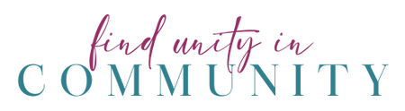
CHERYL’S FAVORITE COLOR IS PINK! LET’S WEAR IT TO SUPPORT HER!

